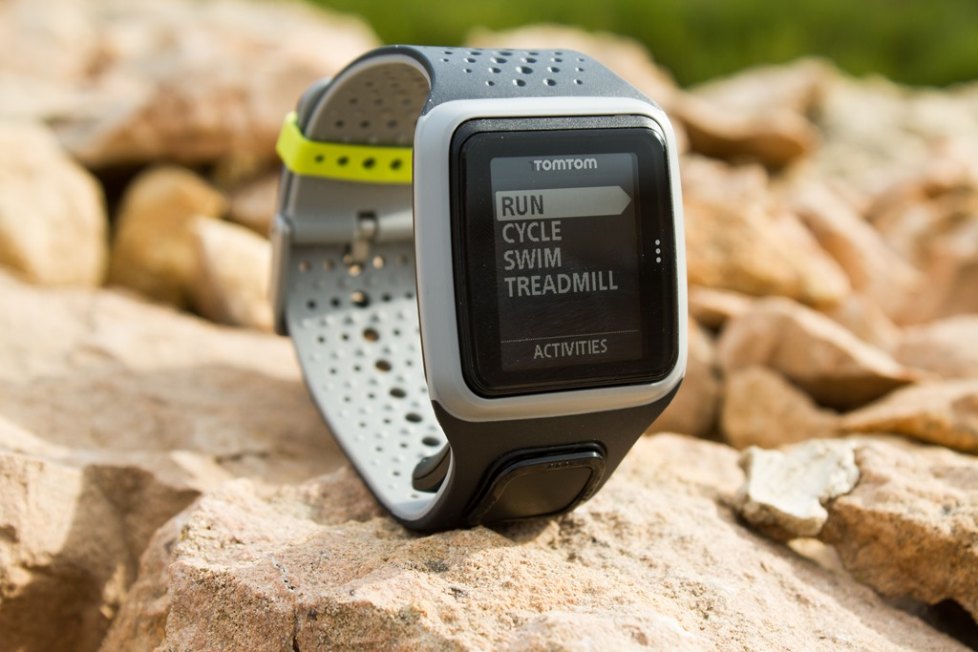Description: TomTom Watch ek mashhoor GPS smartwatch brand Hai jo khas tor par fitness aur outdoor activities Ke Liye design kiya gaya hai. Yeh watch running, cycling, swimming aur hiking jaise activities ko track karne ki salahiyat rakhti hai. Isme built-in GPS, heart rate monitor, aur activity tracking jese features mojood hote Hain jo fitness lovers Ke Liye bohot mufeed Hain. Yeh user-friendly interface aur durable design ke Sath aata hai, jo ise sporty aur rough conditions ke liye behtareen banata hai. Iske ilawa, TomTom Watch mobile app ke zariye data sync karne ki sahulat Bhi deta hai, jisse users apni progress ko asani se monitor kar sakte hain.